🌐 Website Structure for Cross-border Commerce Association

🏠 Home
- Hero banner with your mission tagline (e.g., “Connecting Global Commerce – Empowering International Growth”)
- Quick intro to the Association
- Highlight sections: Upcoming Events | Join the Community | Latest Insights | Strategic Partners
- Call-to-action (CTA): “Become a Member” / “Explore Resources”

🧭 About Us - HEADER
- Mission & Vision - Marcin

At the Cross-Border Commerce Association, our
mission is to empower businesses to thrive in the global marketplace by fostering a collaborative environment where knowledge, experience, and strategic connections drive international growth. We believe that by uniting entrepreneurs, experts, and stakeholders, we can collectively overcome the complexities of international trade and unlock new opportunities.
Our
vision is to be the leading global network for cross-border commerce, recognized for our commitment to facilitating market entry, promoting best practices, and advocating for the interests of our members worldwide. We aspire to create a dynamic ecosystem where businesses can confidently expand their reach, supported by a wealth of shared knowledge and a powerful collective voice.

- Our Goals - Marcin

Our Goals
The Cross-Border Commerce Association is dedicated to achieving the following key goals to support our members and advance international commerce:
- Facilitate Market Expansion: To simplify the process of entering new international markets for companies seeking global expansion. We aim to provide the resources and connections necessary for successful cross-border operations.
- Promote Knowledge Exchange: To serve as a central hub for the exchange of critical knowledge, industry best practices, and up-to-date market and regulatory information among our members.
- Build a Global Business Network: To cultivate a robust and active global network of entrepreneurs, industry experts, and key stakeholders, enabling valuable business connections and collaborative opportunities.
- Advocate for Member Interests: To represent the collective interests of our members in significant policy discussions, international business regulations, and trade facilitation initiatives.
- Deliver Educational Initiatives: To organize and provide impactful educational events, seminars, and workshops designed to foster the development and growth of international trade skills and understanding.
- Support International Enterprise Growth: To actively support enterprises through mentoring, strategic resources, and the establishment of crucial business contacts, enabling their growth on an international scale.
- Drive Synergy and Collaboration: To encourage and promote cooperation among members, with a strong emphasis on international collaboration, recognizing that shared efforts and experiences lead to superior business outcomes globally.
- Promote Global Economic Transfer of Knowledge: To promote the transfer of knowledge in the field of global economics, helping our members develop their skills and achieve better business results.

- Board & Leadership - DAMIAN
- Advisory Committee / Experts - EXPERTS HEADER
Paweł Bilczyński - (Damian) - PL
Olga Pijanowska - (Damian) - ES Specialist
Henning Hessen - (Damian) - DE
Rutger Vonk (Damian) - NL

Nikola Ilhev - Balkans
Romania
Marcel Majsan - Croatia
Daniel Bajer - Baltics
Michele Orzan - Italy
Chingnic - China
Brazil - Marcin check notes

- Statute / Legal Info (to check if publish)

- Strategic Partnerships
Salesupply - short bio - Damian
Consulting Hungary - short bio
FEB -
POWB -

📚 Resources (future)
- Publications: Whitepapers, reports, market guides
- Newsletter Archive
- Case Studies / Success Stories (in the future)
- Regulatory Updates (organized by region or country)
- Knowledge Base / FAQ

🎓 Education
- Training Programs
- Workshops & Webinars (event calendar) - good to have but hidden
- Certification Opportunities (future)

🤝 Community - DAMIAN
- Member Directory (optional gated area)
1.0 - Simple list of members with description
2.0 - something more sophisticate (gated area etc.)
- Online Networking Platform (or integration with a community tool like Circle, Slack, etc.)
- Join the Association
- Member Benefits
- Testimonials / Member Stories

📅 Events
- Upcoming Events (conferences, trade missions, webinars)
- Past Events (with highlights, videos, presentations)
- Partner Events
- Option to register or buy tickets (future)

✉️ News & Insights
- Blog / Articles
Od sierpnia zaczynamy pisać posty SaSU i CHungary jako posty stowarzyesznia i sherujemy w sieci.
- Interviews (future)
- Market Trends (future)

🛠️ Members / Portal (optional gated section) - not needed - HEADER
Logo + nazwa firmy - link do podstrony z krókim opisem członka
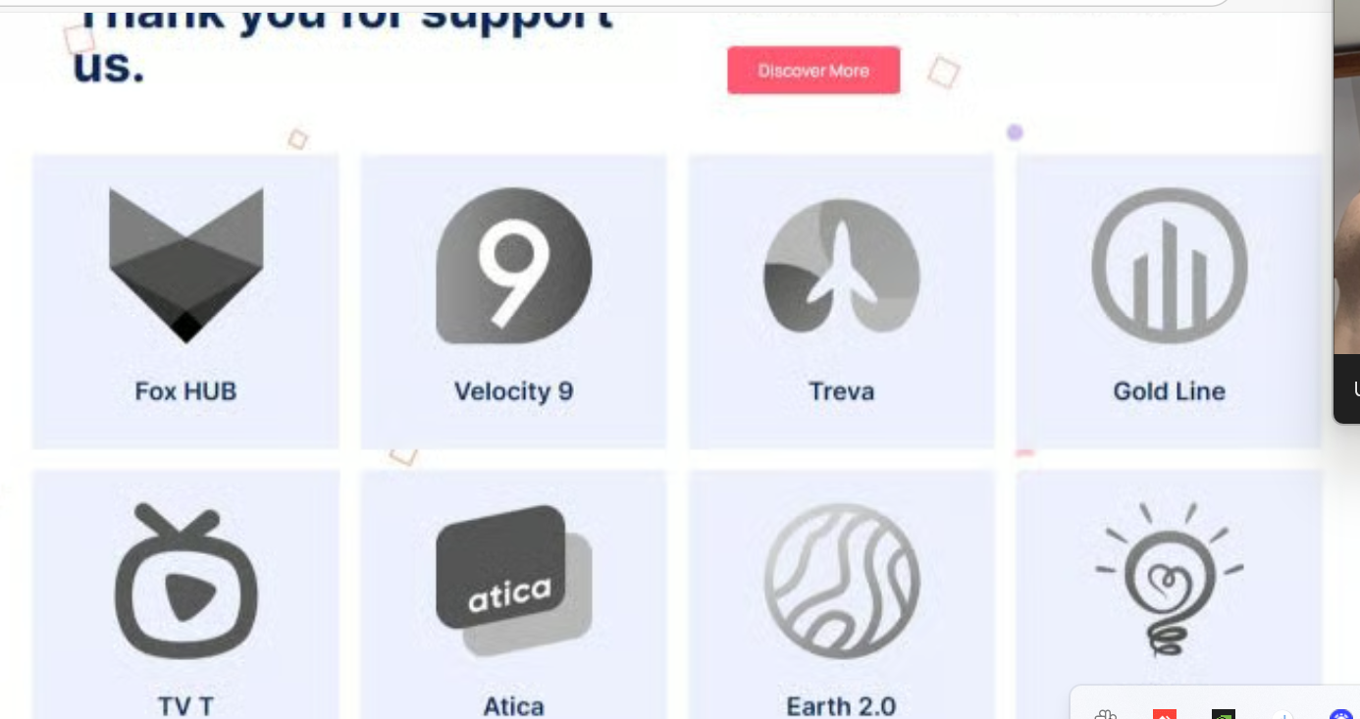
- Personal dashboard
- Access to exclusive content
- Download certificates or documents
- Forum access

📩 Contact
- Contact form
- Address, email, phone
(po założeniu domeny)
- Social media links
DOminika - (po założeniu domeny)
- Newsletter subscription form

🦶 Footer (Global Navigation)
- Quick links (About | Events | Resources | Contact)
- Legal: Privacy Policy | Terms of Use | Cookie Policy
- Social icons (LinkedIn, X, YouTube, etc.)

🛠️ Optional Add-ons (Modern UX Ideas):
- 🔍 Search bar with predictive results
- 🌐 Language switcher (e.g., English / Polish) na strategicznych językach,

UWAGI DO STRONY
HOMPAGE - uklad blogowy (

PODSTRONA EXPERTS (LINK DO HEADERA) - uklad zdjecie opis
Programma - Event & Conference Elementor Template Kit, WP Template Kits ft. event management & event website - Envato

Homepage = blog envato
Experts = speakers experts
Members = logo nazwa on click układ sponsor
Header to navi

EVENTY:
Kalendarz Eventow szczegoly(znaleźć działający kalendarz)

Formularz do wysłania wiadomości w contact us, założyć maila w domenie do którego będzie wysyłane pytania

Ogarnąć footer żeby działały linki

Strona główna nad footerem dodać wpisy z newsami(potrzebne informacje o newsach) dodatkowa strona z newsami

Cała strona po angielsku

Zmniejszyc header

Dodać newsy na glownej pod home
Ogranac tlo w stronie glownej pod home

